­­

Dr. Martin Luther King Jr

January 15, 1929

Dr Martin Luther King Jr was a great man. He had many proffessions. He was a pastor, civil rights leader, husband, father and leader of a great American movement in rights of African Americans.

Martin Luther King was born January 15, 1929 and Died April 4, 1968. His family held several generations as pastors at Ebenezer Baptist Church in Atlanta. Martin served as Co-Pastor from 1960 until his death

Martin went to school in Georgia, and graduation from high school at the age of fifteen. He went to Morehouse College and Boston University. He was elected president of an almost all white senior class. He received his Doctorate Degree in 1955.

He Met his wife Coretta Scott married and had two sons.It was at this time that he became a pastor of Dextor Baptist Church in Montgomery Alabama. He became a strong worker for civil rights.

The Short Bio of Dr. Martin Luther King Jr  
Cristian Portillo-Gonzales

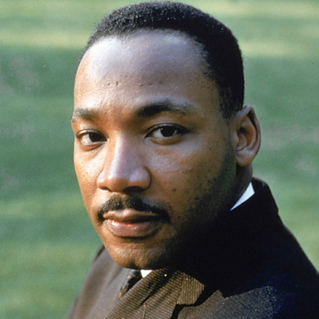

[Martin Luther King Jr.]



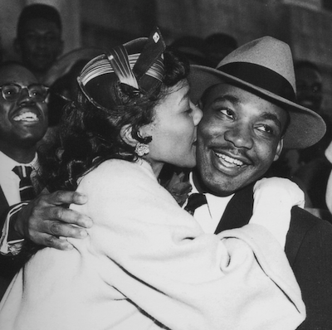

­

The Smith Family  
Street Address, City, ST ZIP Code  
Phone number  
E-mail address

Page 2

HOLIDAY NEWSLETTER 2008



[Put photo caption here]